Jonathan Bennett’s
Robot Control System

Technical Information:

How the Parallel Port Works:
128 64 32 16 8 4 2 1
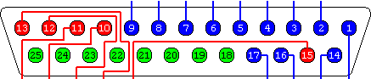
The parallel port pins can be activated (turned on) +5V signal by various programming languages. In Qbasic, to turn on Pins 4 and 5 the command for port 888 would be OUT 888, 5. Similarly, in VisualBasic, the command VbOut is used in the same manner. The pins are numbered according to the binary numbering system. To turn on pins 1-8 you would want 11111111 in binary, which is 255 in decimal.

Finding the Parallel Port Address on a Local Computer:
Go into Device Manager >> Ports (COM & LTP)
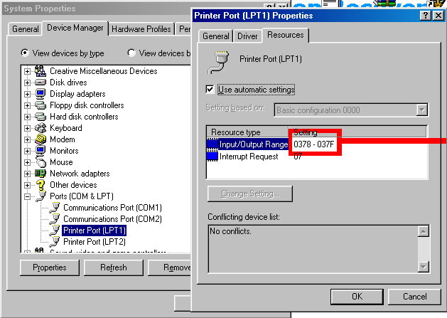Go to Properties of LTP1 >> Resources
Convert the First Number from Hex to Decimal.
378¹⁶ = 888¹⁰

The Most Common Parallel Port Addresses Are:
- 888
- 956
- 658

Note: All School Computers I have tested with have an LTP1 address of 888.

Config.txt
The Parallel Port Address must be set in config.txt. The program looks to config.txt for the address. Parallel port refresh rate can also be changed in config.txt, but the default is recommended.
Connecting the Hardware:
Look for the wire with a bit of red on it on the remote. It is the wire in the plug closest to the bottom of the remote. Plug in according to the diagram.

Plug the other end of the cable in the parallel port of a computer.

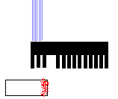REMOTE

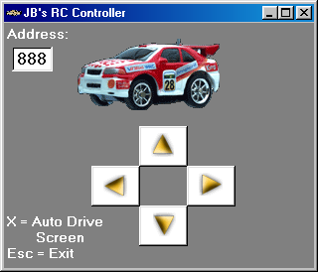
Main Screen:
Displays Parallel Port Address Being Used
Indicator Buttons

This is the Manual Driving Screen. Use UP, DOWN, LEFT and RIGHT Arrows in combination with each other to drive the car, just like a computer game. A-W-S-D can also be used if desired.

When a key is pressed, the appropriate button indicator button will turn blue and the car will move in that direction.

Hit “X” to go to the Auto Drive Screen or
Hit ESCAPE to Exit. (Parallel Port is automatically cleared of transmission on exit.)

Note: Do not run the car on carpet. The wheels get covered in fluff very easy and are not able to move well, if at all.

Auto Drive Screen:

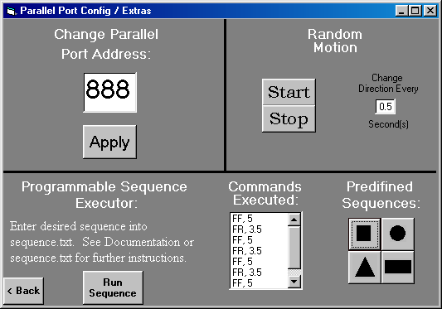

Top Left:
Parallel Port Address being used can temporarily be changed while the program as running. This is useful if you are not sure which address is the correct one and need to try multiple addresses. To change the address permanently, it must be changed in config.txt.

Top Right: Random Motion
Does not serve and practical purpose, but it’s fun to see the car go wild if you set Change Direction to 0.1 or 0.2 seconds.

Bottom: Programmable Sequence Executor
This demonstrates the power of computer controlled motion. This software was written to be a robot control system. With the sequence executor you can program in a series of motions for the robot (in this case, a mini RC car) to follow. If this software were to control a fire station search and rescue robot, a floor plan of the building could be examined and a sequence written to direct the robot to a specific room or place.

See Below for Instructions how to program Sequence.txt.

Commands Executed:
Shows the sequence commands executed. In the screenshot (above), the sequence commands for a square were executed.
Predefined Sequences:
This area of the form contains 4 buttons, that when clicked on perform predefined sequences that make the car move in a specific shape.
Note: The conditions the car is travelling on will alter the shape. These shape sequences were written when the car was on a smooth surface with no obstructions. These shapes have been tested on a wood surface (Ping-Pong table) but no other. The charge of the car’s battery also has an impact of the shape.

Sequence.TXT
Programming A Sequence:

There are 9 basic directions:
FF = Forward
BB = Backward
SS = Stop / Pause
RR = Right (Turns wheels right only)
LL = Left (Turns wheels left only)
FR = Forward and Right
FL = Forward and Left
BR = Backward and Right
BL = Backward and Left

Programming Format is:
Direction, Time
Time is measured in 10ths of a second.

Example:
FF, 100
FR, 50
SS, 30
BB, 50

If this is entered in sequence.txt, the car will travel Forward for 10 seconds, Forward and Right for 5 seconds, Pause for 3 seconds and then move Back for 5 seconds.

Developer’s Note:
This Software is quite versatile and is meant to be a radio controlled robot control system. To demonstrate its use it is being used with a Mini RC Car but could be used for a variety of applications.

